Automated Credit Risk Categorization for
Loan Approval

Project Id: AIML-5

Name : Mohd Uvais Ahmed (Team Leader)
Class Roll Number:50
University Roll Number : 2028770
Section and Group: G G2

Name : Mohammad Rayyan Farooqui
Class Roll Number:49
University Roll Number : 2028768
Section and Group: G G2

- Problem Description 3
- Architecture 4
- Models model 5
- Evaluation metrics used 6
- Preliminary Results and Visualizations 7
- References 10

- Problem Description

In banking systems, approving a loan is an important and risky decision. The bank must determine whether an applicant will repay the loan or default. A wrong decision, especially approving a loan to a defaulter, can lead to financial losses.
Manual evaluation of loan applications is time-consuming and may not always be accurate, especially when dealing with large amounts of data.
This project aims to solve this problem using machine learning by developing a system that predicts whether a loan is safe or risky based on applicant details such as income, credit score, loan amount, and other financial indicators. The goal is to support decision-making by reducing the chances of approving loans to high-risk applicant

- Architecture

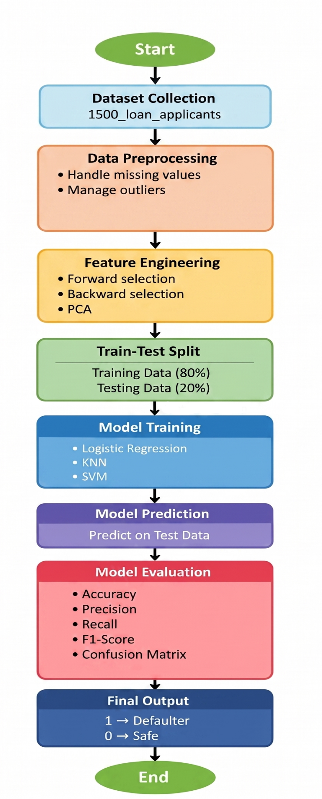
Fig.1 Sample flow diagram.
- Models Used(Applied/ Planned) Give a brief introduction of the models used

- Logistic regression : Logistic Regression is a linear classification algorithm used as a baseline model. It predicts the probability of a loan being safe or risky based on input features and is easy to interpret. It helps in understanding the influence of different factors on loan default.

- KNN : KNN is a distance-based algorithm that classifies a new applicant by comparing it with similar past cases. It assigns the class based on the majority outcome of its nearest neighbours, making it useful for capturing local patterns in the data.

- SVM : SVM is a powerful classification algorithm that finds the optimal boundary between classes. By using different kernels such as linear and RBF, it can handle both simple and complex relationships in the data, making it effective for non-linear patterns.

- Evaluation metrics used:

- Precision
- Recall
- F1 score
- Accuracy
- Confusion matrix
- Classification report

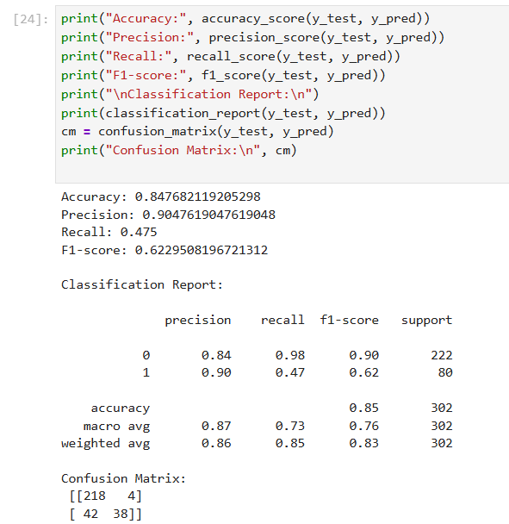

5. Preliminary Results and Visualizations

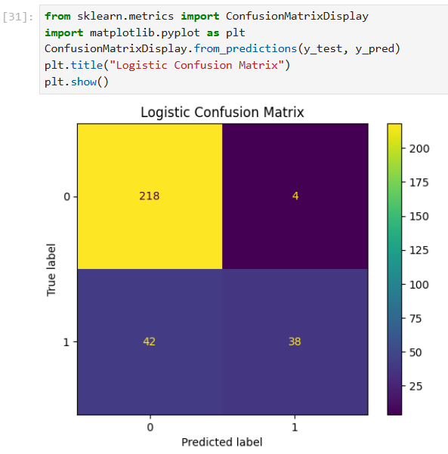

Fig 1. Logistic Confusion matrix

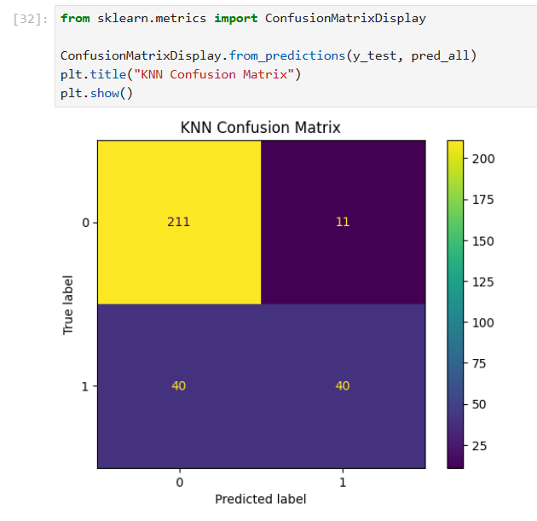.Fig2 . Logistic Confusion matrix

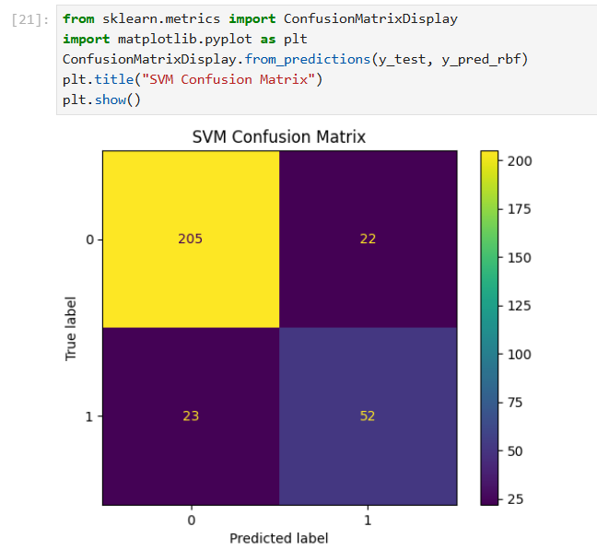

Fig3. SVM Confusion matrix

6. References:
Books:
- Let Us Python – Yashavant Kanetkar

Online Resources:
  - GeeksforGeeks – https://www.geeksforgeeks.org/
  - TutorialsPoint – https://www.tutorialspoint.com/cprogramming/index.htm
  - Stack Overflow – https://stackoverflow.com

